Trello:

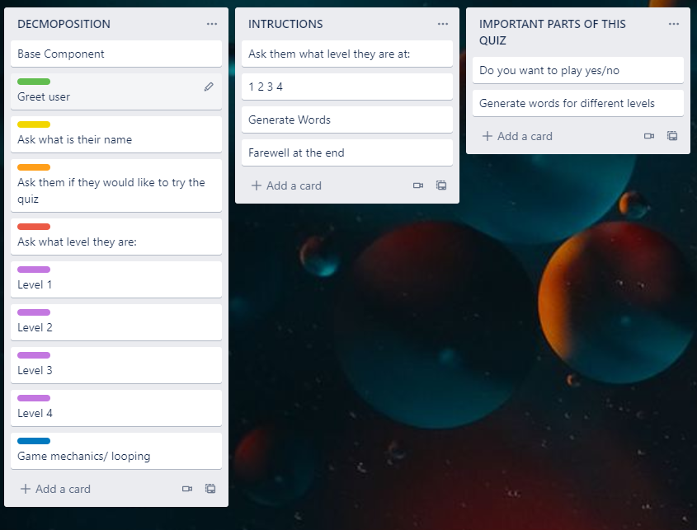

Instructions (and yes / no checker) Test plan

|  |  |
| --- | --- |
| Test case | Expected values |
| -Do you want to play? Maybe  - Do you want to play? Yes | -<error> Please choose y / n  Program continues |
| - Do you want to play? No | Farewell user |

Yes / No trials:

|  |  |
| --- | --- |
| Trial #1 (01_yes_no_v1.py): | This piece of code worked for both UPPER and lowercase characters but was inefficient. It has five if / elif / else statements and quite a bit of repeated code. |
| Trial #2 (01_yes_no_v2): | I used the ‘or’ command to combine my ‘yes’/ ‘y’ statements and this code is more efficient compared with trial #1. |
| Trial #3 (02_yes_no_function_v1): | I made the code from trial 3 into a function which makes it easy to ask more than one yes / no question in a program. I will use this function in my Te Reo Maaori quiz outcome. |

Testing:

|  |  |
| --- | --- |
| Test Data | Expected |
| yes | Program continues |
| y | Program continues |
| no | Program continues |
| n | Program continues |
| maybe | <error> Please choose yes/no |

(What is your name?) (Testing)

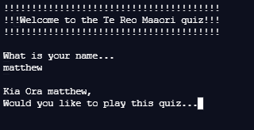

(Do you want to play?) yes/no/maybe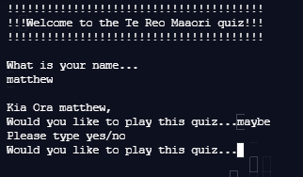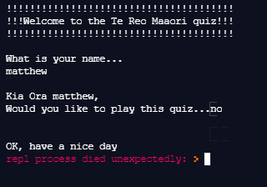

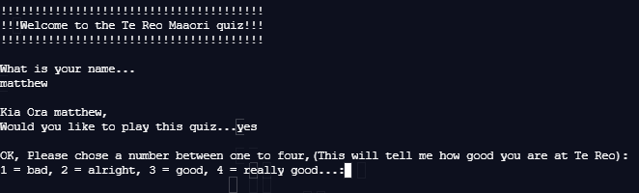

Version 1:

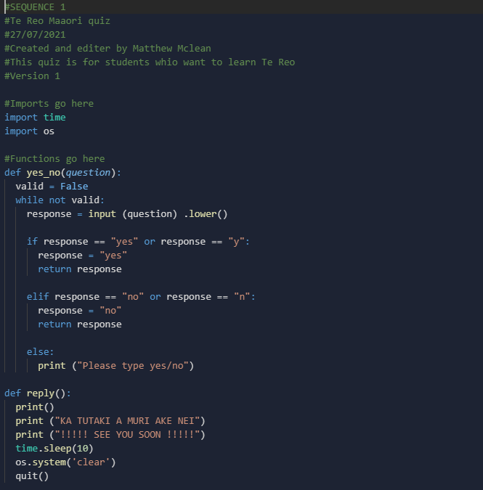

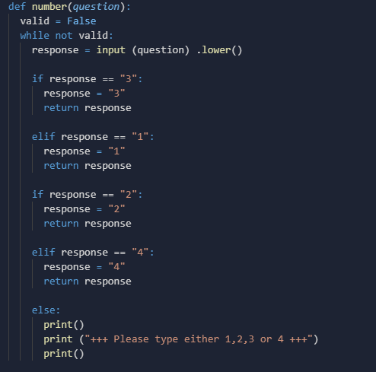

Version 2:

Version 3:

Version 4:

